6B – Driving – Lesson 04
Running Costs & Depreciation – Tables and Graphs.

Name: _________________
- A ute is bought for $40000 and depreciates in a straight line at $5000 p.a.
  - Draw a graph?
Year | Value
Year 0 | $40000
Year 6 | $10000
1
2
3
4
Years
5
6
7
8
$10000
$20000
$30000
$40000

  - After how many years will the ute’s salvage value be nothing? _______

  - What is the salvage value of the ute after 3 years? _______

- A RV is bought for $120,000. The depreciation is $15,000 p.a.
  - Use the formula S = V₀ – Dn to find the salvage value after 5 years.

S = $___ - $___ x 5 = $_______

  - Graph the Salvage value below.
1
2
3
4
Years
5
6
7
8
$30000
$60000
$90000
$120000

a) When will the value be $0? _____ b) What’s the value after 3 years? _____
- A House boat costing $200,000 depreciates at 25% p.a.
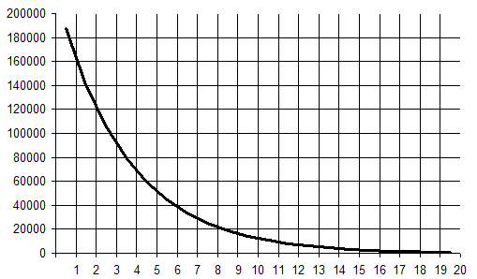
  - What is the salvage value of the House boat after 5 years? $________

  - Does the value ever reach $0. Y / N

  - After how many years is the house boat’s salvage value $4000? ____ years.

- A motor cycle costing $8000 depreciates at 15% per annum.
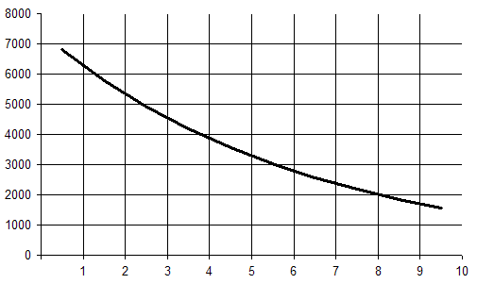

  - What is the value of the motorcycle after 8 years? $_________

  - After how many years does the value fall to $4000? ______ years.

  - When does the value of the motorcycle fall to $0? ______ years.

